Mapping HOT2000 Interface Data to ESP-r’s Data Model
Infiltration

Ian Beausoleil-Morrison
January 22, 2001 (modified January 23, 2001)

This document specifies how to map the HOT2000 interface data to the ESP-r data model for the case of infiltration.

Introduction
In the HOT2000 interface most data related to natural air infiltration are contained within the Natural Air Infiltration node in the house tree structure (see Figure 1). The data are contained within two tabs: specifications and other factors.

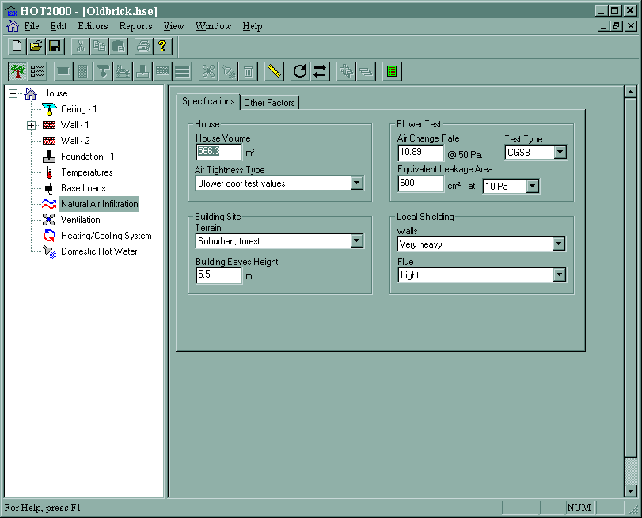

Figure 1: Natural air infiltration node in HOT2000 interface

There are two modelling options for infiltration in the standard release of ESP-r from the University of Strathclyde. Infiltration can be modelled simply by prescribing flow rates, scheduling the flow, and imposing controls. This is known as operations in the ESP-r vernacular and these data are specified in the .opr file. The other approach is much more detailed and requires the description of an air flow network in an .afn file.

Neither the operations nor the network air flow approach will be used in the first release of HOT3000. Rather, a model of intermediate complexity (the Alberta Air Infiltration Model, or AIM-2 for short) has been incorporated into the bpsh3k simulator. Therefore, neither the .opr nor the .afn files are used to described infiltration in HOT3000. Rather, all infiltration data are specified in the .aim file. Note that the .aim file does not exist in ESP-r’s standard data model: it is a HOT3000 addition. A sample .aim file is illustrated in Figure 2.

#
# AIM-2 input file
#
#---Leakage description------------------------------------------------------------------------
1 3.00 10. 0 600.0 # blower door input; 3 ac/h @50Pa; ELA dP=10Pa; ELA not given.
# # Set first number to 6 (and no other data) for energy tight house
#---Leakage distribution-----------------------------------------------------------------------
0 # Use default leakage distribution.
# # Set `1 0.1 0.6 0.2' for user input leakage distribution.
#---Shielding and terrain data-----------------------------------------------------------------
3 7 2 1 10.0
#---Height of building eaves (m)---------------------------------------------------------------
6.0
#---Flue diameters (mm)------------------------------------------------------------------------
200. 150. 0. 75. 50. # furnace, fire#1, fire#2, dhw#1, dhw#2.
#---Zone indices-------------------------------------------------------------------------------
1 # Zone whose temperature used to calculate density of indoor air.
2 1 2 # Total number of zones receiving infil; indices of zones receive infil.
2 # Index of basement zone (=0 if no basement).
#----------------------------------------------------------------------------------------------

Figure 2: Sample .aim file

The remainder of this document describes how to map data from the HOT2000 interface to the .aim file and how to reference the .aim file from the configuration file (.cfg file). This specification should be followed to stream the HOT2000 interface variables the .aim and .cfg files.

Modifications to configuration file
Only a single addition to the .cfg file is required to support infiltration: the .aim file must be identified using the *aim tag. Refer to the red text in Figure 3. Add the *aim tag and file name immediately following the *ctl tag. The file will always be located in the ../aim2 directory and will always be named infiltration.aim. No other changes are required to the .cfg file.

* DATABASES
*prm /usr/esru/esp-r/databases/constr.db1

*mlc ../databases/assemblies.db
*opt /usr/esru/esp-r/databases/optics.db1
*prs /usr/esru/esp-r/databases/pressc.db1
*evn /usr/esru/esp-r/databases/profiles.db1
*clm /usr/esru/esp-r/climate/ottawa.cwec
*pdb /usr/esru/esp-r/databases/plantc.db1
*ctl ../ctl/basement_thermostat.ctl
*aim ../aim2/infiltration.aim
*year 1999 # assessment year

Figure 3: Changes to .cfg file

Creation of infiltration file
The .aim file contains the majority of the data related to infiltration. As described in the above step it is always saved as ../aim2/infiltration.aim.

There are eight rows of data in the .aim file and numerous rows of comments (see Figure 4). All comment lines are prefixed with a # symbol, which must appear in the first column of the row. The comments lines should be streamed to the .aim file as they appear in Figure 4; in other words, these are static data that are written in every case.

#
# AIM-2 input file
#
#---Leakage description-----------------------------------------
a 1 3.00 10. 0 600.
#---Leakage distribution----------------------------------------
b 0
#---Shielding and terrain data----------------------------------
c 3 7 2 1 10.0
#---Height of building eaves (m)--------------------------------
d 6.0
#---Flue diameters (mm)-----------------------------------------
e 200. 150. 0. 75. 50.
#---Zone indices------------------------------------------------
f 1
g 2 1 2
h 2
#---------------------------------------------------------------

Figure 4: Streaming the .aim file

The eight data rows are indicated by blue italicized letters in Figure 4. Note that the blue letters appear in the figure only for clarification purposes and do not represent data that is streamed to the .aim file. The fields of each of these eight rows of data and are described in the following table. The table also indicates how the HOT2000 interface data are to be mapped to these fields.

Note that the mapping of the fields marked in blue needs to be revisited once the geometric mapping approach has been established.

data row | field | description | map from this source in HOT2000 interface | value in HOT2000 interface | value in .aim file | conditions
a | 1 | air tightness description | Natural Air Infiltration/Specifications/House/Air Tightness Type (primary input) and  Natural Air Infiltration/Specifications/Blower Test/Test Type (secondary input) | blower door test “CGSB” | 1 | Integer
 |  |  |  | blower door test “as operated” | 2 | Integer
 |  |  |  | loose | 3 | Integer
 |  |  |  | average | 4 | Integer
 |  |  |  | present | 5 | Integer
 |  |  |  | energy tight | 6 | Integer
a | 2 | ac/h @ 50Pa | Natural Air Infiltration/Specifications/Blower Test/Air Change Rate | numeric | numeric value input | Real.  Only used when air tightness description is blower door or quick blower door.
a | 3 | ELA pressure difference | Natural Air Infiltration/Specifications/Blower Test/Effective Leakage Area at... | 4 Pa | 4. | Real.  Only used when air tightness description is blower door or quick blower door.
 |  |  |  | 10 Pa | 10.
a | 4 | ELA input flag | Natural Air Infiltration/Specifications/Blower Test/Equivalent Leakage Area | 0 | 0 | Integer.  Only used when air tightness description is blower door or quick blower door.
 |  |  |  | > 0 | 1
a | 5 | ELA | Natural Air Infiltration/Specifications/Blower Test/Equivalent Leakage Area | numeric | numeric value input | Real.  Only used when air tightness description is blower door or quick blower door.
b | 1 | Flag indicating whether user has specified leakage distribution | Natural Air Infiltration/Other Factors/Leakage Fractions listbox | use defaults | 0 | Integer.
 |  |  |  | user specified | 1 | Integer.
b | 2 | ceiling leakage fraction | Natural Air Infiltration/Other Factors/Leakage Fractions/Ceilings | numeric | numeric value input | Real.  Only used when leakage distribution specified by user.
b | 3 | wall leakage fraction | Natural Air Infiltration/Other Factors/Leakage Fractions/Walls | numeric | numeric value input | Real.  Only used when leakage distribution specified by user.
b | 4 | floor leakage fraction | Natural Air Infiltration/Other Factors/Leakage Fractions/Floors | numeric | numeric value input | Real.  Only used when leakage distribution specified by user.
c | 1 | terrain at weather station | Natural Air Infiltration/Other Factors/Weather Station/Terrain listbox | Open sea,fetch | 1 | Integer.
 |  |  |  | Mud flats,no vegetation | 2 | Integer.
 |  |  |  | Open flat terrain, grass | 3 | Integer.
 |  |  |  | Low crops | 4 | Integer.
 |  |  |  | High crops, scattered obstacles | 5 | Integer.
 |  |  |  | Parkland, bushes | 6 | Integer.
 |  |  |  | Suburban, forest | 7 | Integer.
 |  |  |  | City centre | 8 | Integer.
c | 2 | terrain at building | Natural Air Infiltration/Specifications/Building Site/Terrain listbox | Open sea,fetch | 1 | Integer.
 |  |  |  | Mud flats,no vegetation | 2 | Integer.
 |  |  |  | Open flat terrain, grass | 3 | Integer.
 |  |  |  | Low crops | 4 | Integer.
 |  |  |  | High crops, scattered obstacles | 5 | Integer.
 |  |  |  | Parkland, bushes | 6 | Integer.
 |  |  |  | Suburban, forest | 7 | Integer.
 |  |  |  | City centre | 8 | Integer.
c | 3 | wall shielding | Natural Air Infiltration/Specifications/Local Shielding/Walls listbox | None | 1 | Integer.
 |  |  |  | Light | 2 | Integer.
 |  |  |  | Heavy | 3 | Integer.
 |  |  |  | Very Heavy | 4 | Integer.
 |  |  |  | Complete | 5 | Integer.
c | 4 | flue shielding | Natural Air Infiltration/Specifications/Local Shielding/Flue listbox | None | 1 | Integer.
 |  |  |  | Light | 2 | Integer.
 |  |  |  | Heavy | 3 | Integer.
 |  |  |  | Very Heavy | 4 | Integer.
 |  |  |  | Complete | 5 | Integer.
c | 5 | anemometer height at weather station | Natural Air Infiltration/Other Factors/Weather Station/Anemometer Height | numeric | numeric value input | Real.
d | 1 | height of building eaves | Natural Air Infiltration/Specifications/Building Site/Building Eaves Height | numeric | numeric value input | Real.
e | 1 | furnace flue diameter | Heating-Cooling System/Furnace/Flue Diameter | numeric | numeric value input | Real.
e | 2 | fireplace #1 flue diameter | Heating-Cooling System/Solid Fuel/Flue Diameter for first Equipment Type | numeric | numeric value input | Real.
e | 3 | fireplace #2 flue diameter | Heating-Cooling System/Solid Fuel/Flue Diameter for second Equipment Type | numeric | numeric value input | Real.
e | 4 | primary DHW flue diameter | Domestic Hot Water/Primary/Flue Diameter | numeric | numeric value input | Real.
e | 5 | secondary DHW flue diameter | Domestic Hot Water/Secondary/Flue Diameter | numeric | numeric value input | Real.
f | 1 | Reference zone for infiltration calculations | No current field holds this data | No current field holds this data | 1 (assumes zone 1 represents living space) | Integer
g | 1 | Number of zones receiving infiltration | No current field holds this data | No current field holds this data | 2 (assumes zone 1 represents living space, zone 2 represents basement, and zone 3 represents attic and that attic receives no infiltration) | Integer
g | 2 | Index of first zone receiving infiltration | No current field holds this data | No current field holds this data | 1 (assumes zone 1 represents living space) | Integer
g | 3 | Index of second zone receiving infiltration | No current field holds this data | No current field holds this data | 2 (assumes zone 2 represents basement) | Integer
h | 1 | Index of basement zone | No current field holds this data | No current field holds this data | 2 (assumes zone 2 represents basement) | Integer

